**HCI ASSIGNMENT – 2**

Course No: CSE 4849

Members:

Fardin Saad (154419)

Md. Alamin Shaheen (154423)

Rahat Anwar Khan (154431)

Rafayat Ahmed (154436)

HCI Project: **Music Playback based on Emotion Recognition**

Ques. What type of prototype we used and justify it?

* We used low fidelity prototyping. Low-fidelity (lo-fi) prototyping is a quick and easy way to translate high-level design concepts into tangible and testable artifacts. The first and most important role of lo-fi prototypes is to check and test functionality rather than the visual appearance of the product.

**Balsamiq** Mockups is a user interface design tool for creating wireframes (also called mockups or low-fidelity **prototypes**). You can use it to generate digital sketches of your product ideas to facilitate discussion and understanding before any code is written.

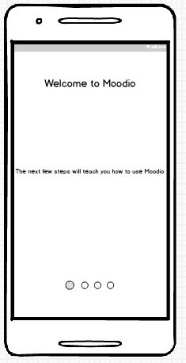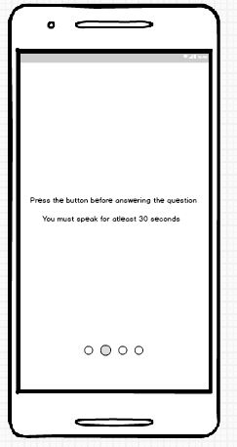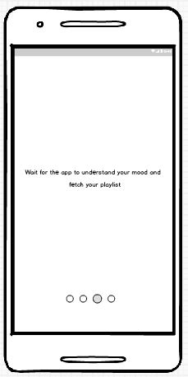

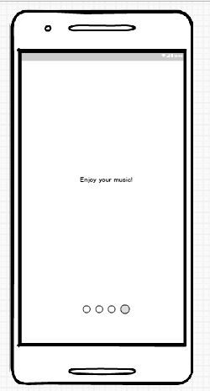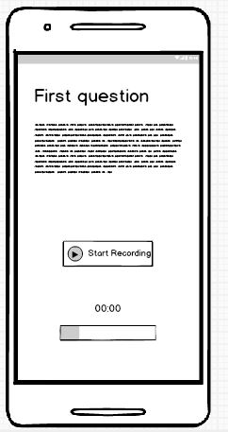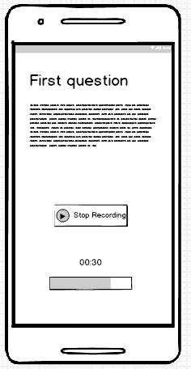

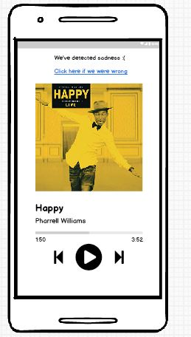

The prototype which we have constructed is named as Moodio. In these software designed sketches we can see that the user is asked a question. The user is required to answer the question within a minute. After the user clicks on stop recording the sytem processes the recorded audio sample of the user to detect his/her emotions. After detecting an emotion the system plays an appropriate song to corroborate the users feelings.

In this interface we have shown that we detected sadness. Thus the upbeat song of Pharell Williams was playing to cheer the user.